**For this analysis, I generated a population data set of size 500 using a gamma distribution.  
  
The population mean calculated from this data set is approximately 468.22.**

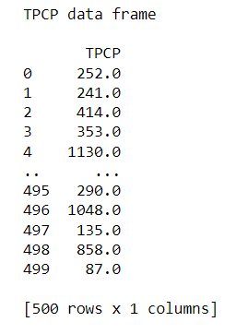

I then made a histogram in order to visualize the distribution of the population data, which was used to show that it is indeed skewed.

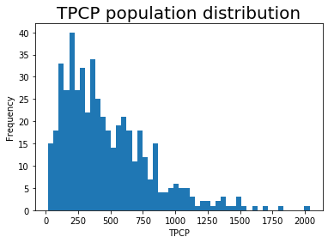

I then selected a random sample of size 50 from the population and calculated its mean, which is approximately 467.2 This sample mean closely approximates the population mean, which is expected due to the large sample size.  
Next, I repeated the sampling process 1000 times, each time with the same sample size of 50, and calculated the mean of each sample which were then stored in a data frame.

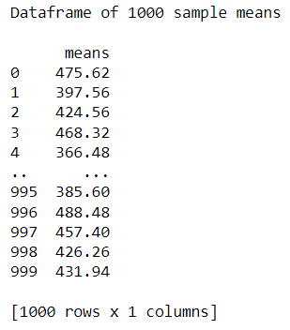

With this information, I created a histogram to visualize the distribution of the 1000 sample means. The distribution appears to be approximately normal, or bell shaped, which can confirm the first part of the central limit theorem.

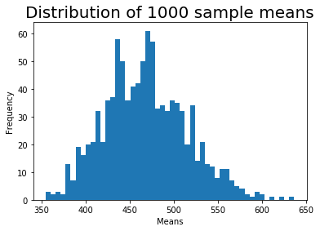

The grand mean, or the mean of the 1000 sample means, is approximately 468.08, and the standard deviation is approximately 47.318. The grand mean closely approximates the population mean, which confirms the second part of the central limit theorem.  
  
**Probabilities related to the sample means using the normal distribution:**

The probability of a sample mean being less than 370 is ~0.00741.  
The probability of a sample mean being greater than 510 is ~0.30085.  
The probability of a sample mean being between 495 and 550 is ~0.33304.

**Critical values for the sample means:**

The sample mean A, such that the probability of a sample mean being less than A is 0.15, is ~436.260.  
The sample mean B, such that the probability of a sample mean being greater than B is 0.01, is ~595.380.

Based off of the results that I received from this data, I was able to demonstrate key parts of the central limit theorem. The distribution of sample means is approximately normal regardless of the shape of the population distribution, and the average of all sample means closely approximates the population mean.